7805 REGULATED POWER SUPPLY

CIRCUIT DIAGRAM

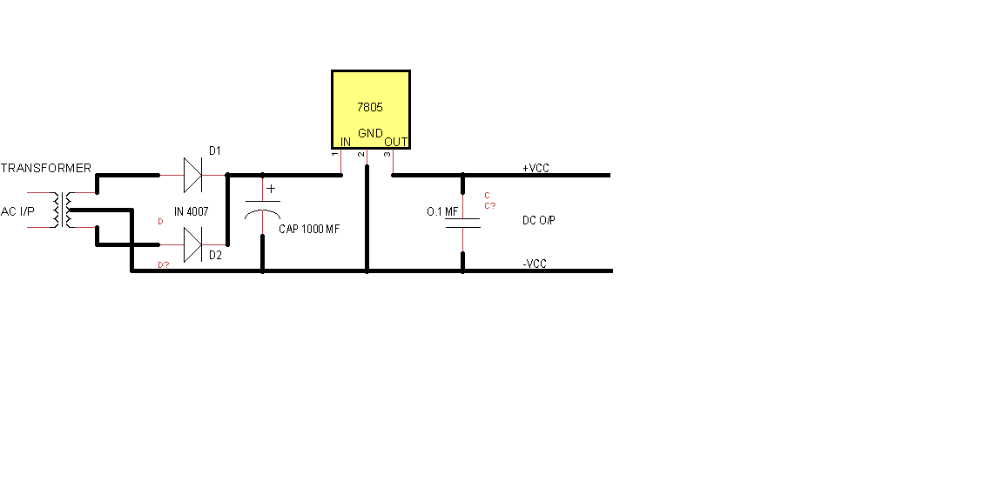

A full-wave rectifier is a device that has two or more diodes arranged so that load current flows in the same direction during each half cycle of the ac supply.

we need to rectify AC power to obtain the full use of both half-cycles of the sine wave, a different rectifier circuit configuration must be used. Such a circuit is called a full-wave rectifier. One kind of full-wave rectifier, called the center-tap design, uses a transformer with a center-tapped secondary winding and two diodes, as in Figure below.
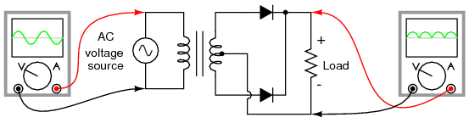
Full-wave rectifier, center-tapped design.
This circuit's operation is easily understood one half-cycle at a time. Consider the first half-cycle, when the source voltage polarity is positive (+) on top and negative (-) on bottom. At this time, only the top diode is conducting; the bottom diode is blocking current, and the load “sees” the first half of the sine wave, positive on top and negative on bottom. Only the top half of the transformer's secondary winding carries current during this half-cycle as in Figure below.
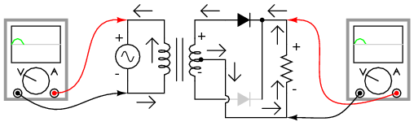
Full-wave center-tap rectifier: Top half of secondary winding conducts during positive half-cycle of input, delivering positive half-cycle to load..
During the next half-cycle, the AC polarity reverses. Now, the other diode and the other half of the transformer's secondary winding carry current while the portions of the circuit formerly carrying current during the last half-cycle sit idle. The load still “sees” half of a sine wave, of the same polarity as before: positive on top and negative on bottom. (Figure below)
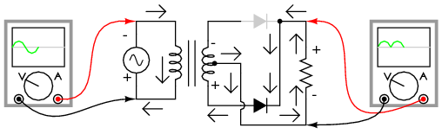
Full-wave center-tap rectifier: During negative input half-cycle, bottom half of secondary winding conducts, delivering a positive half-cycle to the load.

The pulsating DC is connected across a filter capacitor which removes the ripples and smoothens the DC output

Regulator section.
A DC power supply system, which maintains constant voltage irrespective of fluctuations in the main supply or variation in the load, is known as Regulated Power supply.

The 7805 IC referred to fixed positive voltage regulator, which provides fixed voltage 5 volts. The 7805 regulator is known as fixed voltage regulator.

Fixed –Voltage regulator design has been greatly simplified by the introduction of 3-terminal regulator ICs such as the 78xx series of positive regulators and the 79xxx series of negative regulators, which incorporate features such as built-in fold back current limiting and thermal protection, etc. These ICs are available with a variety of current and output voltages ratings, as indicated by the ‘xxx’ suffix; current ratings are indicated by the first part of the suffix and the voltage ratings by the last two parts of the suffix. Thus, a 7805 device gives a 5V positive output at a 1mA rating, and a 79L15 device gives a 15V negative output at a 100mA rating.

3-terminal regulators are very easy to use. The regulators ICs typically give about 60dB of ripple rejection, so 1V of input ripple appears as a mere 1mV of ripple on the regulated output.

A rectified filter and unregulated DC voltage is given to pin of IC regulator. A bypass capacitor is connected between input and ground to bypass the ripples and oscillations. The output capacitor is connected between output and ground to improve transient response. The unregulated input is applied to the IC must be always more than the regulated output.
The regulated 5v power supply is connected to microcontroller, timer, op amps or other circuits of the project.

